Low Cohesion

📌 Definition:
# Source: AI Source: Provided by: [Data Path: Persons Table -> ID Column: 1, Name_En Column: Motasem Essam] -> From: [Chatgpt (GPT‑5 Mini)] on [12/9/2025]
Low Cohesion occurs when a class or module handles multiple unrelated tasks, causing its elements to be loosely connected or scattered.

🧠 Simple idea:
# Source: AI Source: Provided by: [Data Path: Persons Table -> ID Column: 1, Name_En Column: Motasem Essam] -> From: [Chatgpt (GPT‑5 Mini)] on [12/9/2025]
“Everything is mixed together” ⚠️

🔍 Key characteristics:
# Source: AI Source: Provided by: [Data Path: Persons Table -> ID Column: 1, Name_En Column: Motasem Essam] -> From: [Chatgpt (GPT‑5 Mini)] on [12/9/2025]
- Class/module has multiple responsibilities
- ❌ Harder to maintain, test, and reuse
- ❌ Reduces readability and clarity
- ❌ Increases risk of errors when making changes

📊 Example:
# Source: AI Source: Provided by: [Data Path: Persons Table -> ID Column: 1, Name_En Column: Motasem Essam] -> From: [Chatgpt (GPT‑5 Mini)] on [12/9/2025]
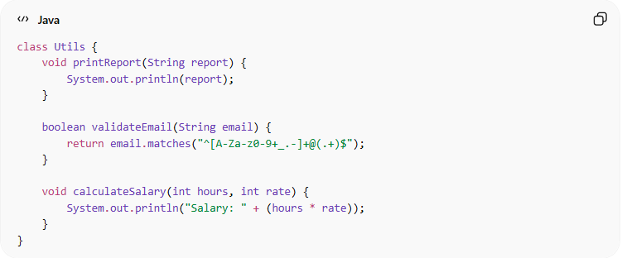
class Utils {
void printReport(String report) {
System.out.println(report);
}

boolean validateEmail(String email) {
return email.matches("^[A-Za-z0-9+_.-]+@(.+)$");
}

void calculateSalary(int hours, int rate) {
System.out.println("Salary: " + (hours * rate));
}
}
- ❌ Utils handles reporting, email validation, and salary calculation
- ❌ Low cohesion because methods are unrelated

⚙️ Best Practice:
# Source: AI Source: Provided by: [Data Path: Persons Table -> ID Column: 1, Name_En Column: Motasem Essam] -> From: [Chatgpt (GPT‑5 Mini)] on [12/9/2025]
- Split classes/modules into smaller, focused units
- Ensure each class/module has a single responsibility
- Keep methods closely related to the class purpose
- Aim for high cohesion to improve maintainability and clarity

